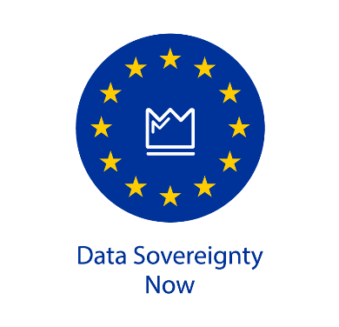

PRESS RELEASE

New Coalition Launches Campaign for Data Sovereignty Now
Group Urges Policy Makers on Data Sovereignty in EU Data Strategy
Amsterdam, 21 January 2021 – Today, a coalition of leading Europe-based technology companies, research institutions and not-for-profit organizations announced the launch of Data Sovereignty Now (DSN), a campaign that will press European policy makers at all levels to ensure that control of data remains in the hands of the people and organizations that generate it. The issue becomes ever more urgent as policies around Europe’s digital economy and data architecture start to solidify.
"Data sovereignty is going to realign the 'data benefit balance' by creating a level playing field in today's digital economy,” said Lars Nagel, CEO of the International Data Spaces Association and one of the initiators of Data Sovereignty Now. “This will stimulate new commercial growth, healthier competition and vibrant innovation. We believe that the European Commission should take a decisive step forwards by making data sovereignty the foundation for every data initiative in Europe.”
The Data Sovereignty Now coalition includes: aNewGovernance, FreedomLab, INNOPAY, International Data Spaces Association, iSHARE, Meeco, MyData Global, Finnish Innovation Fund Sitra, The Chain Never Stops, TNO and the University of Groningen.
The group plans to target European policy makers, influencers and interest groups to achieve its goal of ensuring that the people and organisations that generate data can also maintain control over it. A robust awareness and activation campaign is planned, including webinars, round tables and other events, as well as a full range of educational materials, including a web site and blogs, research and thought leadership and discussions with media.
The time is now. The European Commission is currently preparing new legislation in the domain of data sharing. The Data Sovereignty Now partners firmly believe that the principle of data sovereignty—the right/ability of individuals and organizations to decisively control the data they generate—will play a key role in not only securing the rights of individuals over their data, but also providing significant stimulus for the digital economy.

The Data Sovereignty Now Point of View
Currently, a handful of global players enjoy a virtual monopoly on the exploitation of data. The Data Sovereignty Now partners believe that data sovereignty should become the central guiding principle of the data economy and a prerequisite for every organization’s data architecture.
Data sovereignty is formally defined as “the capability of an entity (natural person or corporate) to be entirely ​self-determined with regard to its data”. This means people and organizations should have unified, practical and effective solutions to determine for themselves how their data is used. And they should have the tools to manage, control and create value from their personal and business data.

How to take control of data
Data sovereignty can be achieved by creating a 'soft' infrastructure. This soft infrastructure consists of functional, legal, technical and operational agreements between public and private parties to make control of data possible. Solutions for sharing data will adhere to a clear framework. These types of agreements are necessary to facilitate the sorts of controls we already have when are using online payment tools, e.g. transferring money.
But the soft infrastructure that the Data Sovereignty Now campaign is targeting will operate at a much larger scale, across sectors and borders. This will centre around a unified user experience, similar to the types of unified digital behaviours that we use for phoning, messaging and paying.
The Data Sovereignty Now recommendations are key to building a vibrant digital economy, equipping Europe with the tools and applications to enable better decisions and outcomes across the nine European data spaces: industry, environment, mobility, health, finance, energy, agriculture, public administration and education.

About Data Sovereignty Now:
Data Sovereignty Now is a campaign of a coalition of private, non-profit and research partners, dedicated to achieving data sovereignty as a core principle of the European data economy today and in the future.
For further information, please reach out to us at contact@datasovereigntynow.org or visit www.datasovereigntynow.org.

